***Hook’s Law (1)***

**Aims:**

1- Verification Hook’s law

2- Determine the elastic constant of spring

**Introduction:**

**Types of materials**

1- Elastic materials 2- Inelastic (Plastic) materials

**Stress:** The force passing per unit area (F/A dyne/cm2)

**Strain:** relative change in dimension

**Types of strains**

1- Linear (longitudinal) strain

2- Volumetric (bulk) strain

3- Shear strain

**Linear strain** = change in length / origin length (∆L/Lo)

**Hook’s law**: the stress directly proportional with strain

**Law**

F = K ∆L 🡪 ∆L= g/K . m

Where

F applied force (dyne)

m mass of load (gm)

K elastic constant (dyne/cm)

∆L change in length (elongation or stretch)

**Apparatus:**

Spiral spring Meter scale Loads

**Method:**

1- Read the initial length of spring Lo

2- Add load on the pan of spring (m=20 gm)

3- Take the length of the spring L

4- Calculate the change in length (extension) ∆L=L-Lo

3- Repeat the steps 2, 3 and 4 for other loads (m= 40, 60 …. gm)

4- Draw the relation between m & ∆L

6- Calculate the elastic constant from K = 980/slope (dyne/cm)

**Table:** **Graph:**

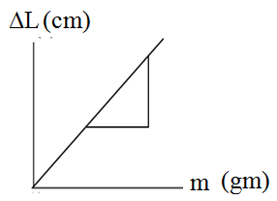Lo= -- cm

|  |  |  |
| --- | --- | --- |
| m (gm) | L  (cm) | ∆L=L-Lo  (cm) |
| 0  20  40  60  80  100  120 | Lo | 0 |

**Results:**

1- The relation between change in length and loads is straight line, that is verify Hook’s law (F α ∆L)

2- Elastic constant K = 980/slope = ------- (dyne/cm)